The Beat Tower

Allison, Autumn, Zack
12/5/14

Summary

The beat tower is a single frequency audio spectrum volume meter. It can isolate around a certain frequency and display it on a creative 8 segment LED bar graph. It is built around the Arduino Open Source Environment.

Table of Contents

- Introduction
- Uses
- Code
- Pictures
- Conclusion
- References
- Appendices

- Introduction

Our group juggled with the idea on what project to choose because we weren’t sure what we really wanted. Autumn saw an idea for the beat tower online and Zack liked the idea because music is awesome. Once we started, we broke up the work with Autumn taking over building the tower, Allison worked on the code, and Zack tackled the circuitry. We all pitched in with the speech assignment. When one needed help the others pitched in and over all we were a well-oiled machine.

- Uses

The main use our product has is to be a party center piece. It lights up to the beat of the music translating the high pitch to the top lights and the bass on the lower lights. It is basically a very low-tech light bar. It will turn any boring party into a very fun one. If you are not planning on having parties any time soon, no problems. Whether you listen to music to pump you up, sooth you, or just for the entertainment, the beat tower enhances all of these experiences.

- Code

#include <avr/pgmspace.h>
//#include "fix_fft.h"
#include <WProgram.h>

/* fix_fft.c - Fixed-point in-place Fast Fourier Transform */
/*
All data are fixed-point short integers, in which -32768
to +32768 represent -1.0 to +1.0 respectively. Integer
arithmetic is used for speed, instead of the more natural
floating-point.

For the forward FFT (time -> freq), fixed scaling is
performed to prevent arithmetic overflow, and to map a 0dB
sine/cosine wave (i.e. amplitude = 32767) to two -6dB freq
coefficients. The return value is always 0.

For the inverse FFT (freq -> time), fixed scaling cannot be
done, as two 0dB coefficients would sum to a peak amplitude
of 64K, overflowing the 32k range of the fixed-point integers.
Thus, the fix_fft() routine performs variable scaling, and
returns a value which is the number of bits LEFT by which
the output must be shifted to get the actual amplitude
(i.e. if fix_fft() returns 3, each value of fr[] and fi[]
must be multiplied by 8 (2**3) for proper scaling.
Clearly, this cannot be done within fixed-point short
integers. In practice, if the result is to be used as a
filter, the scale_shift can usually be ignored, as the
result will be approximately correctly normalized as is.

*/

#define N_WAVE 256 /* full length of Sinewave[] */
#define LOG2_N_WAVE 8 /* log2(N_WAVE) */

int led[] = {5,6,7,8,9,10,11,12};

int x = 0;

char im[128], data[128];

char data_avgs[14];

int i=0,val;

#define AUDIOPIN 3

void setup()
{
for (int i = 0; i <8; i++)
{
pinMode(led[i], OUTPUT);
}
Serial.begin(9600);

}

void loop()
{
for (i=0; i < 128; i++){
val = analogRead(AUDIOPIN);
data[i] = val;
im[i] = 0;
}

fix_fft(data,im,7,0);

for (i=0; i< 64;i++){
data[i] = sqrt(data[i] * data[i] + im[i] * im[i]); // this gets the absolute value of the values in the
//array, so we're only dealing with positive numbers
};

// average bars together
for (i=0; i<14; i++) {
data_avgs[i] = data[i*4] + data[i*4 + 1] + data[i*4 + 2] + data[i*4 + 3]; // average together

data_avgs[i] = map(data_avgs[i], 0, 30, 0, 9); // remap values for LoL
}
int value = data_avgs[0];//0 for bass
ledArray(value);
}
void ledArray(int input)
{
//
if (input > 8)
{
for (int i = 0; i <8; i++)
{
digitalWrite(led[i], HIGH);
}
}
else if (input > 7)
{
for (int i = 0; i <7; i++)
{
digitalWrite(led[i], HIGH);
}
for (int i = 7; i <8; i++)
{
digitalWrite(led[i], LOW);
}
}
else if (input > 6)
{
for (int i = 0; i <6; i++)
{
digitalWrite(led[i], HIGH);
}
for (int i = 6; i <8; i++)
{
digitalWrite(led[i], LOW);
}
}
else if (input > 5)
{
for (int i = 0; i <5; i++)
{
digitalWrite(led[i], HIGH);
}
for (int i = 5; i <8; i++)
{
digitalWrite(led[i], LOW);
}
}
else if (input > 4)
{
for (int i = 0; i <4; i++)
{
digitalWrite(led[i], HIGH);
}
for (int i = 4; i <8; i++)
{
digitalWrite(led[i], LOW);
}
}
else if (input > 3)
{
for (int i = 0; i <3; i++)
{
digitalWrite(led[i], HIGH);
}
for (int i = 3; i <8; i++)
{
digitalWrite(led[i], LOW);
}
}
else if (input > 2)
{
for (int i = 0; i <2; i++)
{
digitalWrite(led[i], HIGH);
}
for (int i = 2; i <8; i++)
{
digitalWrite(led[i], LOW);
}
}
else if (input > 1)
{
for (int i = 0; i <1; i++)
{
digitalWrite(led[i], HIGH);
}
for (int i = 1; i <8; i++)
{
digitalWrite(led[i], LOW);
}
}
else
{
for (int i = 0; i <8; i++)
{
digitalWrite(led[i], LOW);
}
}
}

#define N_WAVE 256 /* full length of Sinewave[] */
#define LOG2_N_WAVE 8 /* log2(N_WAVE) */

/*
Since we only use 3/4 of N_WAVE, we define only
this many samples, in order to conserve data space.
*/

const prog_int8_t Sinewave[N_WAVE-N_WAVE/4] PROGMEM = {
0, 3, 6, 9, 12, 15, 18, 21,
24, 28, 31, 34, 37, 40, 43, 46,
48, 51, 54, 57, 60, 63, 65, 68,
71, 73, 76, 78, 81, 83, 85, 88,
90, 92, 94, 96, 98, 100, 102, 104,
106, 108, 109, 111, 112, 114, 115, 117,
118, 119, 120, 121, 122, 123, 124, 124,
125, 126, 126, 127, 127, 127, 127, 127,

127, 127, 127, 127, 127, 127, 126, 126,
125, 124, 124, 123, 122, 121, 120, 119,
118, 117, 115, 114, 112, 111, 109, 108,
106, 104, 102, 100, 98, 96, 94, 92,
90, 88, 85, 83, 81, 78, 76, 73,
71, 68, 65, 63, 60, 57, 54, 51,
48, 46, 43, 40, 37, 34, 31, 28,
24, 21, 18, 15, 12, 9, 6, 3,

0, -3, -6, -9, -12, -15, -18, -21,
-24, -28, -31, -34, -37, -40, -43, -46,
-48, -51, -54, -57, -60, -63, -65, -68,
-71, -73, -76, -78, -81, -83, -85, -88,
-90, -92, -94, -96, -98, -100, -102, -104,
-106, -108, -109, -111, -112, -114, -115, -117,
-118, -119, -120, -121, -122, -123, -124, -124,
-125, -126, -126, -127, -127, -127, -127, -127,

/*-127, -127, -127, -127, -127, -127, -126, -126,
-125, -124, -124, -123, -122, -121, -120, -119,
-118, -117, -115, -114, -112, -111, -109, -108,
-106, -104, -102, -100, -98, -96, -94, -92,
-90, -88, -85, -83, -81, -78, -76, -73,
-71, -68, -65, -63, -60, -57, -54, -51,
-48, -46, -43, -40, -37, -34, -31, -28,
-24, -21, -18, -15, -12, -9, -6, -3, */
};

/*
FIX_MPY() - fixed-point multiplication & scaling.
Substitute inline assembly for hardware-specific
optimization suited to a particluar DSP processor.
Scaling ensures that result remains 16-bit.
*/
inline char FIX_MPY(char a, char b)
{

//Serial.println(a);
//Serial.println(b);

/* shift right one less bit (i.e. 15-1) */
int c = ((int)a * (int)b) >> 6;
/* last bit shifted out = rounding-bit */
b = c & 0x01;
/* last shift + rounding bit */
a = (c >> 1) + b;

/*
Serial.println(Sinewave[3]);
Serial.println(c);
Serial.println(a);
while(1);*/

return a;
}

/*
fix_fft() - perform forward/inverse fast Fourier transform.
fr[n],fi[n] are real and imaginary arrays, both INPUT AND
RESULT (in-place FFT), with 0 <= n < 2**m; set inverse to
0 for forward transform (FFT), or 1 for iFFT.
*/
int fix_fft(char fr[], char fi[], int m, int inverse)
{
int mr, nn, i, j, l, k, istep, n, scale, shift;
char qr, qi, tr, ti, wr, wi;

n = 1 << m;

/* max FFT size = N_WAVE */
if (n > N_WAVE)
return -1;

mr = 0;
nn = n - 1;
scale = 0;

/* decimation in time - re-order data */
for (m=1; m<=nn; ++m) {
l = n;
do {
l >>= 1;
} while (mr+l > nn);
mr = (mr & (l-1)) + l;

if (mr <= m)
continue;
tr = fr[m];
fr[m] = fr[mr];
fr[mr] = tr;
ti = fi[m];
fi[m] = fi[mr];
fi[mr] = ti;
}

l = 1;
k = LOG2_N_WAVE-1;
while (l < n) {
if (inverse) {
/* variable scaling, depending upon data */
shift = 0;
for (i=0; i<n; ++i) {
j = fr[i];
if (j < 0)
j = -j;
m = fi[i];
if (m < 0)
m = -m;
if (j > 16383 || m > 16383) {
shift = 1;
break;
}
}
if (shift)
++scale;
} else {
/*
fixed scaling, for proper normalization --
there will be log2(n) passes, so this results
in an overall factor of 1/n, distributed to
maximize arithmetic accuracy.
*/
shift = 1;
}
/*
it may not be obvious, but the shift will be
performed on each data point exactly once,
during this pass.
*/
istep = l << 1;
for (m=0; m<l; ++m) {
j = m << k;
/* 0 <= j < N_WAVE/2 */
wr = pgm_read_word_near(Sinewave + j+N_WAVE/4);

/*Serial.println("asdfasdf");
Serial.println(wr);
Serial.println(j+N_WAVE/4);
Serial.println(Sinewave[256]);

Serial.println("");*/

wi = -pgm_read_word_near(Sinewave + j);
if (inverse)
wi = -wi;
if (shift) {
wr >>= 1;
wi >>= 1;
}
for (i=m; i<n; i+=istep) {
j = i + l;
tr = FIX_MPY(wr,fr[j]) - FIX_MPY(wi,fi[j]);
ti = FIX_MPY(wr,fi[j]) + FIX_MPY(wi,fr[j]);
qr = fr[i];
qi = fi[i];
if (shift) {
qr >>= 1;
qi >>= 1;
}
fr[j] = qr - tr;
fi[j] = qi - ti;
fr[i] = qr + tr;
fi[i] = qi + ti;
}
}
--k;
l = istep;
}
return scale;
}

/*
fix_fftr() - forward/inverse FFT on array of real numbers.
Real FFT/iFFT using half-size complex FFT by distributing
even/odd samples into real/imaginary arrays respectively.
In order to save data space (i.e. to avoid two arrays, one
for real, one for imaginary samples), we proceed in the
following two steps: a) samples are rearranged in the real
array so that all even samples are in places 0-(N/2-1) and
all imaginary samples in places (N/2)-(N-1), and b) fix_fft
is called with fr and fi pointing to index 0 and index N/2
respectively in the original array. The above guarantees
that fix_fft "sees" consecutive real samples as alternating
real and imaginary samples in the complex array.
*/
int fix_fftr(char f[], int m, int inverse)
{
int i, N = 1<<(m-1), scale = 0;
char tt, *fr=f, *fi=&f[N];

if (inverse)
scale = fix_fft(fi, fr, m-1, inverse);
for (i=1; i<N; i+=2) {
tt = f[N+i-1];
f[N+i-1] = f[i];
f[i] = tt;
}
if (! inverse)
scale = fix_fft(fi, fr, m-1, inverse);
return scale;
}

- Pictures
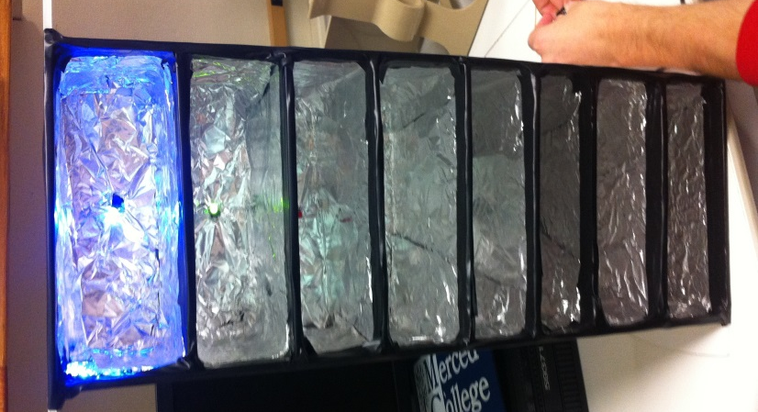

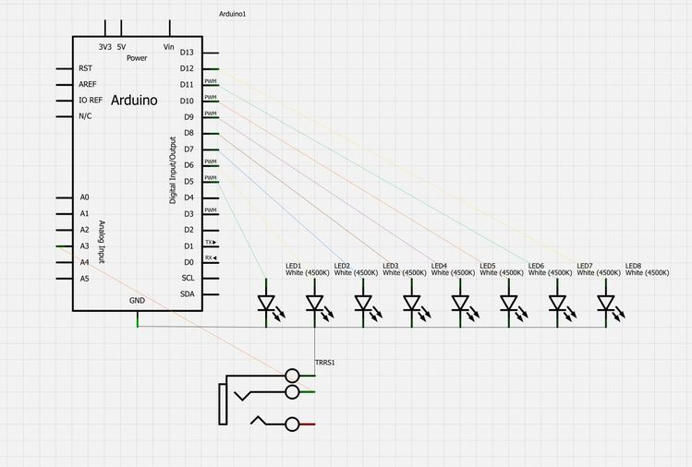
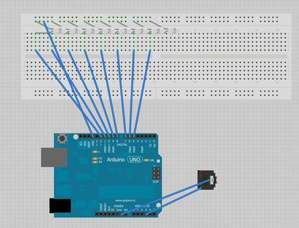

- Conclusion

By far the biggest problem we had was the code. As Ms. Kanemoto can attest to, the code was not bad at first but soon became a monster. The problem was it used a function that our Arduino program did not recognize. Besides that the only other hump we had to get over was the connection with the wires. Our decision was to use electrical tape when in hind sight we probably should have soldered the wires together. In all, things went pretty smoothly and our project turned out to work very well.

- References

- http://www.instructables.com/file/FZWBXPZH5F2ZERD

- http://forum.arduino.cc/index.php/topic,38153.0.html

- Ms. Kanemoto’s office hours

- Appendices

- Title Page ………………………………… 1
- Introduction ……………………………. 2
- Uses ………………………………………… 3
- Code ………………………………………… 4-11
- Pictures…………………………………….. 12
- Conclusion………………………………… 13
- References………………………………… 13
- Appendices ………………………………. 14

